SYSTEM-LEVEL SOFTWARE DESIGN SPECIFICATION
Kaching
Point-of-Sale Application
Document purpose: Define the system-wide architecture, technology choices, interfaces, data strategy, security controls, deployment topology, and design conventions that all Kaching features must follow.

Field | Value
Document | System-Level Software Design Specification
Version | 0.1
Status | Sample Draft for Editing
Date | 17 August 2026
Prepared by | [Student Name]
Product | Kaching

Design baseline
- Current SRS containing FR-001 to FR-038, BR-001 to BR-020, and NFR-001 to NFR-011.
- Feature Inventory containing Feature-A to Feature-R.
- Approved additions for administration, barcode-based product entry, global catalog pricing, capacity, recovery, connectivity, and English-only user interface.

Document Control
Version | Date | Author | Summary
0.1 | 17 Aug 2026 | [Student Name] | Initial system-level design based on the approved SRS and clarification decisions.

Contents
- 1. Introduction
- 2. Architectural Drivers
- 3. System Context
- 4. Architecture Overview
- 5. Deployment Architecture
- 6. Application Structure
- 7. Data Architecture
- 8. Integration Design
- 9. Security Design
- 10. User Interface Standards
- 11. Observability and Operations
- 12. Performance, Availability, and Recovery
- 13. Development and Delivery
- 14. System Test Strategy
- 15. Feature Allocation
- 16. Key Design Decisions and Risks
- 17. Required Upstream SRS Amendments
- 18. References

1. Introduction

1.1 Purpose
This SDS defines the system-level design for Kaching, a multi-store point-of-sale application. It translates the approved requirements and feature inventory into a coherent technical architecture. It intentionally stops short of screen-by-screen, class-level, and endpoint-level feature specifications, which belong in later feature design documents.

1.2 Scope
Kaching supports counter checkout, order-level discounts, Thai VAT-inclusive totals, cash and credit-card payments, durable sale recording, receipt printing, asynchronous inventory updates, daily sales reporting, product and price maintenance, operational exception monitoring, auditing, and administration of users, stores, and terminals.

1.3 Exclusions
- Returns, refunds, and refund receipts.
- Customer Service Counter integration.
- Split payments.
- Synchronous inventory-availability checking.
- Offline sale processing when a terminal cannot reach the Kaching backend.

1.4 Intended Audience
The intended readers are software engineers, architects, database designers, testers, DevOps engineers, security reviewers, instructors, and future feature-design authors.

1.5 Terms
Term | Meaning
PSP | Payment Service Provider, represented by K-Bank in this design.
ECR | Electronic cash register protocol used to send a payment amount to a card terminal and receive a result.
Outbox | A database record written in the same transaction as a completed sale and later published asynchronously.
Peripheral Gateway | A terminal-side Node.js service that connects the browser workflow to the card machine and receipt printer.
Business date | The calendar date in Asia/Bangkok used for store reporting.

2. Architectural Drivers

2.1 Business and Design Goals
- Keep checkout fast and simple for store staff.
- Prevent duplicate card charges when a payment outcome is uncertain.
- Guarantee that every completed sale has a durable inventory-update record.
- Allow inventory processing to continue asynchronously when the Inventory Service is unavailable.
- Support multiple stores and terminals from one centrally managed application.
- Use a design that is realistic for production while remaining understandable and maintainable as a student project.

2.2 Fixed Constraints and Assumptions
Area | Decision
Frontend | React, TypeScript, and Vite.
Backend | Node.js, Express, and TypeScript.
Persistence | PostgreSQL accessed through Prisma ORM.
Hosting | Centralized Google Cloud deployment using containerized services and Cloud SQL.
Messaging | RabbitMQ with durable queues and publisher confirmations.
Connectivity | A terminal must reach the Kaching backend to start or complete a sale.
Integrations | Production-style interfaces for K-Bank, the card machine, receipt printer, and Inventory Service.
Language | English-only user interface; Thai currency, VAT, and Asia/Bangkok business time.
Catalog | One global product catalog and one global selling price per product.

2.3 Quality and Capacity Targets
Quality area | Target
Scale | 20 stores, 10 active terminals per store, and 200 concurrent users.
Throughput | At least 20 completed sales per second across the organization.
Checkout response | 95 percent of non-external checkout actions complete within 2 seconds.
Availability | 99.5 percent monthly availability for the Kaching backend.
Recovery point | RPO of 15 minutes.
Recovery time | RTO of 4 hours.
Display | Desktop and touchscreen friendly at 1280 x 720 or higher.
Accessibility | WCAG 2.1 AA color contrast and keyboard-operable workflows.

3. System Context
Kaching is the system of record for checkout transactions and their payment status. It does not own inventory balances or cardholder data. The Inventory Service owns stock balances, while K-Bank and the card machine own sensitive payment processing.
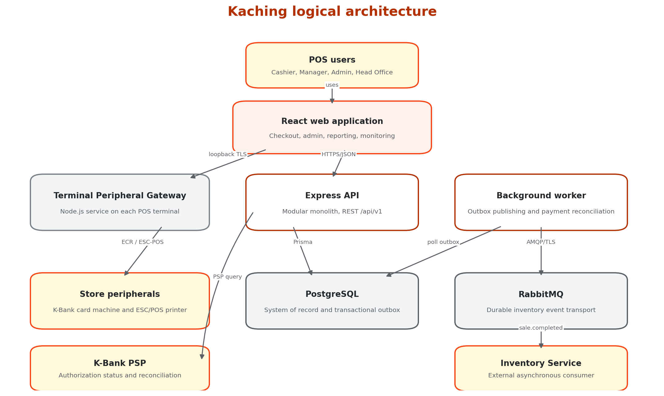
Figure 1. Kaching logical architecture

3.1 External Actors and Systems
Actor or system | Responsibility | Interaction
Cashier | Operates checkout and payment workflows. | React web application
Manager | Views assigned-store summaries and maintains authorized product data. | React web application
Administrator | Maintains users, roles, stores, terminals, and cross-store access. | React web application
Head-Office Manager | Views selected-store and consolidated reports. | React web application
K-Bank card machine and PSP | Authorizes card payment and supports transaction-status queries. | Peripheral Gateway and PSP adapter
Receipt printer | Prints sales receipts. | Peripheral Gateway
Inventory Service | Consumes completed-sale messages and adjusts stock. | RabbitMQ

4. Architecture Overview

4.1 Architectural Style
Kaching uses a modular monolith for the business API, plus a separately deployed background worker and terminal-side Peripheral Gateway. This avoids premature microservice complexity while preserving clear module boundaries and independent scaling for asynchronous work.
Primary design rule: PostgreSQL is the source of truth. External calls must never be used as substitutes for durable local state, and a completed sale must be committed atomically with its inventory outbox record.

4.2 Major Runtime Components
Component | Deployment | Responsibility
React Web | Browser UI | Checkout, administration, reporting, and operational monitoring.
Kaching API | Cloud Run service | Authentication, authorization, business rules, REST API, sale finalization, reporting, and integration coordination.
Background Worker | Cloud Run worker service or worker pool | Outbox publication, message retry, card-payment reconciliation, and scheduled operational checks.
Peripheral Gateway | Node.js service on each POS terminal | Secure local access to card machine, barcode scanner, and receipt printer.
PostgreSQL | Cloud SQL | Authoritative transactional data, audit records, and outbox.
RabbitMQ | Managed quorum cluster | Durable at-least-once delivery of inventory events.

4.3 Layering and Dependency Rules
- Presentation code may call application services only through typed API clients.
- Express route handlers perform transport concerns and delegate business work to application services.
- Domain services contain rules and state transitions without depending directly on Express or RabbitMQ.
- Repositories isolate Prisma persistence operations.
- Integration adapters isolate K-Bank, terminal, printer, and RabbitMQ-specific contracts.
- Modules may exchange identifiers and documented interfaces, but must not query another module's tables directly through ad hoc SQL.

4.4 Suggested Backend Modules
Module | Core responsibilities
identity | Authentication, users, roles, store assignments, and session management.
organization | Stores, terminals, terminal registration, and operational context.
catalog | Global products, barcodes, prices, VAT configuration, and product search.
sales | Open carts, sale items, totals, discounts, cancellation, and sale state.
payments | Cash, card attempts, PSP adapters, uncertain outcomes, and reconciliation.
receipts | Receipt payload generation, print attempts, and reprints.
inventoryIntegration | Outbox records, RabbitMQ publication, retry, and status.
reporting | Store-level and consolidated daily summaries.
operations | Exception queues, system-health information, and recovery actions.
audit | Append-only security and business audit events.

5. Deployment Architecture
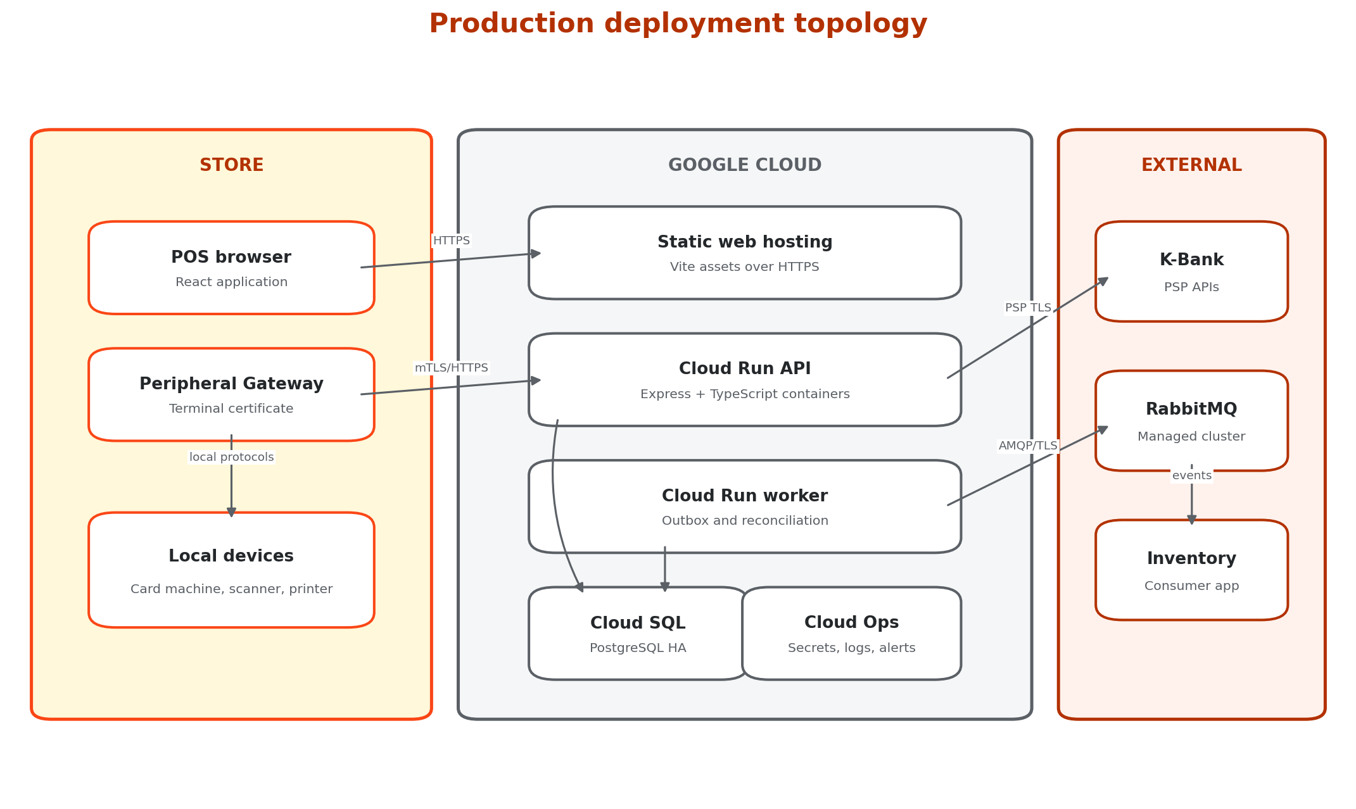
Figure 2. Production deployment topology

5.1 Production Topology
- The Vite production build is served as static assets over HTTPS using Google Cloud static hosting and CDN capabilities.
- The Express API runs in stateless containers on Cloud Run and scales horizontally.
- The background worker runs separately so message publication and reconciliation cannot consume checkout request capacity.
- Cloud SQL for PostgreSQL uses regional high availability, automated backups, and point-in-time recovery.
- RabbitMQ runs as a managed, TLS-protected, three-node quorum cluster in or near the selected GCP region.
- Each POS terminal runs a registered Peripheral Gateway with a terminal-specific certificate and outbound network access only.

5.2 Environment Separation
Environment | Purpose | Data policy
Development | Local implementation and automated tests using Docker Compose. | Synthetic data only.
Staging | Production-like integration, acceptance, load, and recovery testing. | Masked or synthetic data only.
Production | Live store operations. | Production data with restricted access and backup controls.

5.3 Connectivity Behavior
Kaching does not support offline checkout. If a terminal loses connectivity to the API, the web application shall disable sale start and completion actions, preserve any already displayed cart in memory for operator reference, and show a clear reconnect status. The cart is not treated as durable until the backend confirms it.

6. Application Structure

6.1 Frontend Structure
Area | Design
Framework | React with TypeScript and Vite.
Routing | Role-aware routes for checkout, catalog, reports, operations, and administration.
State | Server state through a query/cache layer; local component state for transient UI input.
Forms | Schema-based client validation matched to API contracts.
Money | API monetary values are decimal strings; the UI formats them as THB and never uses binary floating-point for financial calculations.
Errors | Inline validation for correctable input and persistent banners/dialogs for transaction-state or integration errors.
Accessibility | Keyboard navigation, visible focus, touch targets of at least 44 by 44 CSS pixels, and announced status changes.

6.2 REST API Convention
- Base path: /api/v1.
- JSON property names: camelCase.
- Timestamps: ISO 8601 in UTC; business-date interpretation uses the store timezone.
- Money: decimal strings with two fractional digits, for example "1250.00".
- Errors: a consistent problem-detail object containing code, title, message, fieldErrors, correlationId, and retryable.
- Idempotency: Idempotency-Key is mandatory for payment-attempt creation and sale finalization.
- Concurrency: mutable aggregate requests include a version value; stale updates return HTTP 409.
- Documentation: OpenAPI 3.1 is generated and checked in CI.

6.3 API Resource Outline
Resource area | Representative endpoints
Authentication | POST /auth/login, POST /auth/refresh, POST /auth/logout, GET /me
Sales | POST /sales, GET /sales/{id}, PATCH /sales/{id}/items, POST /sales/{id}/cancel, POST /sales/{id}/finalize
Payments | POST /sales/{id}/payment-attempts, POST /payment-attempts/{id}/terminal-result, GET /payment-attempts/{id}
Catalog | GET /products, POST /products, PATCH /products/{id}
Reports | GET /reports/daily-sales?date=&storeId=, GET /reports/daily-sales/consolidated?date=
Operations | GET /operations/payment-recovery, GET /operations/inventory-outbox
Administration | Users, role assignments, stores, and terminals under /admin.

7. Data Architecture
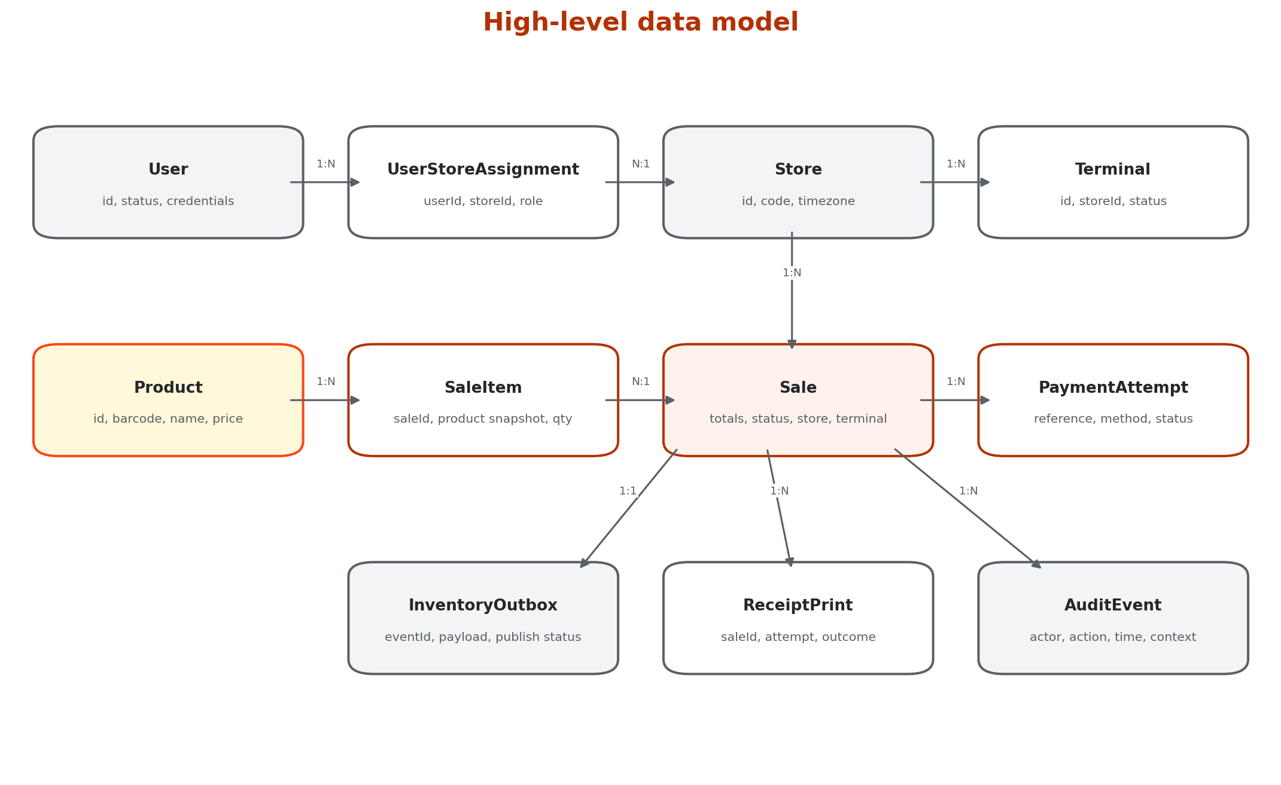
Figure 3. High-level data model

7.1 Core Entity Design
Entity | Key design notes
User | Authentication identity, active status, and security metadata. Roles and store scope are assigned separately.
Store | Stable code, name, active status, and Asia/Bangkok timezone.
Terminal | Belongs to one store and has a unique registration identity and active status.
Product | Global SKU, barcode, name, VAT rate or category, VAT-inclusive price, and active status.
Sale | Authoritative transaction aggregate with subtotal, discount, VAT, total, state, store, terminal, cashier, timestamps, and version.
SaleItem | Snapshots SKU, name, unit price, VAT information, quantity, and line amount so history is unaffected by later catalog changes.
PaymentAttempt | Unique merchant reference, method, requested amount, PSP reference, status, timestamps, and reconciliation metadata.
InventoryOutbox | Unique event ID, sale ID, event version, payload, state, attempt count, next attempt time, and last error.
ReceiptPrint | Print and reprint attempts, terminal, user, outcome, and error details without card data.
AuditEvent | Append-only actor, action, target, store, terminal, timestamp, correlation ID, and non-sensitive details.

7.2 Identifier and Monetary Strategy
- Use UUID primary keys for distributed uniqueness across stores and terminals.
- Optionally expose a human-readable sale number containing store code, business date, terminal code, and sequence, while retaining UUID as the technical key.
- Use PostgreSQL NUMERIC and Prisma Decimal for money. JavaScript number is not used for persisted financial calculations.
- Round percentage-derived discounts to two decimal places using commercial half-up rounding unless Thai statutory tax guidance requires a different rule.
- Persist the VAT rate and calculated VAT portion used by the sale so historical receipts remain reproducible.

7.3 Sale State Model
State | Meaning | Allowed next states
OPEN | Cart may be edited or cancelled. | PAYMENT_PENDING, CANCELLED
PAYMENT_PENDING | A cash confirmation or card attempt is in progress. | OPEN, PAYMENT_RECOVERY_PENDING, COMPLETED, CANCELLED where safe
PAYMENT_RECOVERY_PENDING | Card result is uncertain or approved payment cannot be finalized. | PAYMENT_PENDING, COMPLETED
COMPLETED | Payment succeeded and sale plus outbox were committed atomically. | None
CANCELLED | Sale was cancelled before completion. | None

7.4 Transaction Boundaries
Sale finalization transaction: In one PostgreSQL transaction, validate the current aggregate version and payment state, mark the sale COMPLETED, insert the inventory outbox record, and append required audit data. A failure rolls back the complete operation.

The system creates and commits a pending card PaymentAttempt before it sends any request to the terminal or PSP. This durable reference supports recovery when the external result arrives but local sale finalization fails.

8. Integration Design

8.1 K-Bank Card Payment
The production integration is isolated behind PaymentTerminalAdapter and PaymentProviderAdapter interfaces. Exact message formats, certificates, endpoints, terminal protocols, timeout values, and settlement procedures must follow the contracted K-Bank specification and certification process. The SDS does not invent provider-specific fields.
- API creates a durable PaymentAttempt with a unique merchant reference.
- The web application sends a signed payment instruction to the registered local Peripheral Gateway.
- The gateway sends amount and reference to the card machine through the approved ECR protocol.
- The gateway returns the terminal result and provider reference to the API over an authenticated channel.
- The API records the result and finalizes an approved sale atomically with the inventory outbox.
- On timeout or disconnection, the attempt becomes unresolved and the worker queries K-Bank using the original merchant reference.
- No new card attempt or cash payment is permitted until the uncertain result is resolved.

8.2 Peripheral Gateway
- Runs as a managed Node.js and TypeScript service on each registered POS terminal.
- Exposes only a loopback TLS endpoint to the local browser and validates short-lived signed instructions from the API.
- Uses a terminal-specific certificate and refuses instructions for another terminal or store.
- Implements adapters for the K-Bank ECR protocol and ESC/POS-compatible printer driver.
- Never logs PAN, track data, PIN data, card verification values, or full provider payloads containing sensitive data.
- Reports health and device status without allowing arbitrary commands from the browser.

8.3 Receipt Printing
After completion, the API produces a receipt view model from the immutable sale snapshot. The web application sends a signed print job to the Peripheral Gateway. A print failure creates a failed ReceiptPrint record but never changes the sale from COMPLETED. Reprints require authorization and are logged.

8.4 Inventory Messaging
The inventory integration uses a transactional outbox and at-least-once RabbitMQ delivery. The Inventory Service must process messages idempotently using eventId or saleId plus event type.
Element | Design
Exchange | kaching.inventory, durable topic exchange.
Routing key | sale.completed.v1
Queue | inventory.sale.completed.v1, durable quorum queue.
Message | Persistent JSON message containing schemaVersion, eventId, saleId, storeId, terminalId, occurredAt, and item quantities.
Publishing | Worker uses mandatory routing and asynchronous publisher confirms.
Retry | Exponential backoff with jitter; PostgreSQL retains the outbox row until broker confirmation.
Consumer failure | RabbitMQ retains or redelivers unacknowledged messages.
Poison message | Rejected non-retryable messages move to a dead-letter queue and create an operational alert.

8.5 Failure-Handling Matrix
Failure | Required behavior | Operator visibility
Backend unreachable | Do not start or complete sales. Show reconnect status. | Checkout banner
PSP unavailable before request | Disable card option; allow cash or cancellation. | Checkout message
Card response unknown | Block further payment; reconcile original reference. | Recovery-pending state
Approved card, finalization failed | Do not charge again; reconcile and finalize from durable attempt. | Payment recovery queue
Printer failure | Keep sale completed; permit authorized reprint. | Print failure message and audit
RabbitMQ unavailable | Keep outbox pending and retry. | Inventory exception queue
Inventory consumer unavailable | RabbitMQ retains durable message until consumption resumes. | Broker monitoring
Outbox message rejected | Move to dead-letter handling and alert operations. | Failed inventory message

9. Security Design

9.1 Authentication and Session Security
- Passwords are hashed using Argon2id with current organization-approved parameters.
- Short-lived access tokens and rotating refresh tokens are stored in Secure, HttpOnly, SameSite cookies.
- State-changing requests use CSRF protection and server-side authorization checks.
- Disabled users, stores, or terminals cannot create sessions or submit transactions.
- Secrets and certificates are stored in Google Secret Manager or the secured terminal certificate store, never in source control.

9.2 Authorization
Role | System-wide access summary
Cashier | Checkout, permitted discounts, cash and card payments, and receipt printing.
Manager | Cashier functions, assigned-store daily summary, and authorized catalog maintenance.
Administrator | User, role, store, terminal, catalog, cross-store reporting, and operational exception access.
Head-Office Manager | Selected-store and consolidated reporting; operational access if separately granted.

9.3 Payment-Data Controls
Card-data boundary: Kaching stores only merchant reference, PSP reference, approved or declined status, amount, masked display data when contractually permitted, and timestamps. It does not store PAN, track data, PIN/PIN block, or card verification values.

The terminal, Peripheral Gateway, network path, and software involved in payment processing must follow the acquirer's certification requirements and the applicable PCI DSS scope. Sensitive authentication data must not be stored after authorization.[5]

9.4 Audit and Privacy
- Audit events are append-only and include actor, role, store, terminal, action, target, time, correlation ID, and outcome.
- Audit details exclude passwords, tokens, card data, and unnecessary personal data.
- Access to audit and operational data is itself authorized and logged.
- Production logs use structured redaction rules before export to centralized logging.

10. User Interface Standards

10.1 Theme and Visual Tokens
The official KMUTT colors for websites and applications are Orange #FA4616, Yellow #FFC72C, and Blue Grey #7B8189.[1] Kaching uses these brand colors with derived accessible neutrals and a darker orange for white-text controls.
Token | Value | Usage
brand.orange | #FA4616 | Brand accents, selected indicators, large headings, and icons.
brand.yellow | #FFC72C | Highlights and warning surfaces with dark text.
brand.blueGrey | #7B8189 | Borders, secondary accents, and large secondary text.
action.primary | #B33100 | Primary button background with white text; derived for AA contrast.
text.primary | #24272A | Normal body text.
surface.default | #FFFFFF | Cards, forms, and primary work surfaces.
surface.subtle | #F2F4F5 | Secondary panels and table striping.
status.success | #1F7A4D | Successful payment and completed sale status.
status.error | #B42318 | Declines, failures, and blocked actions.

10.2 Checkout Layout Convention
- Use a two-region layout: product and cart workspace on the left, totals and action panel on the right.
- Keep subtotal, discount fields, VAT, and final total continuously visible.
- Place the final total in the strongest visual hierarchy and do not communicate state by color alone.
- Use large touch targets, visible keyboard focus, and scanner-friendly default focus behavior.
- Require confirmation for destructive actions such as cancelling a sale or deactivating a terminal.
- Use plain English and persistent recovery messages for uncertain card outcomes; never invite the cashier to retry while status is unknown.

10.3 Product Entry
The checkout screen accepts product entry through a keyboard-wedge USB barcode scanner, manual barcode entry, or product search by code or name. All three paths resolve the same global product record and current global selling price.

11. Observability and Operations

11.1 Structured Logging
Every API request and worker job receives a correlation ID. Logs are structured JSON and include service, environment, correlationId, saleId where applicable, terminalId, storeId, severity, event name, duration, and sanitized error details.

11.2 Metrics and Alerts
Signal | Example alert
API availability and latency | Error rate or p95 latency exceeds the defined threshold.
Payment recovery backlog | Any unresolved payment older than the operational threshold.
Outbox backlog | Pending count or oldest-message age exceeds threshold.
RabbitMQ health | Broker unavailable, quorum degraded, publish nack, or unroutable message.
Dead-letter queue | Any new inventory message enters the DLQ.
Database | Connection exhaustion, replication issue, storage growth, or failed backup.
Terminal gateway | Registered terminal has not reported health within threshold.

11.3 Operational Work Queues
Feature-P provides separate views for payment-recovery items and inventory-publication items. Operators may inspect status and retry eligible technical operations. They may not manually force a card result or alter a completed sale.

12. Performance, Availability, and Recovery

12.1 Performance Design
- Perform cart arithmetic in the browser for immediate feedback and revalidate all values on the server.
- Index Sale by storeId, completedAt, status, and payment method for daily summaries.
- Index Product by normalized barcode, SKU, active status, and searchable name fields.
- Use bounded database connection pools sized for Cloud Run scaling limits.
- Keep report queries read-only and paginated where detailed data is exposed.
- Load-test at 200 concurrent users and 20 completed sales per second, including outbox writes.

12.2 Availability Behavior
Dependency | Kaching behavior when unavailable
Kaching API or Cloud SQL | No new sale may start or complete.
K-Bank PSP | Card payment unavailable; cash remains available if the Kaching backend is healthy.
RabbitMQ | Sales continue because the outbox remains durable in PostgreSQL.
Inventory Service | Sales continue; RabbitMQ retains messages until the consumer recovers.
Receipt printer | Sales continue and remain completed; reprint is available later.

12.3 Backup and Disaster Recovery
- Use Cloud SQL automated backups and point-in-time recovery with settings capable of meeting the 15-minute RPO.[3]
- Use regional high availability for Cloud SQL and test failover behavior at least annually.
- Retain infrastructure definitions, container images, Prisma migrations, and configuration outside the database so services can be recreated.
- Document a recovery runbook that restores PostgreSQL, redeploys API and worker revisions, validates RabbitMQ connectivity, and checks payment and outbox backlogs.
- Perform a scheduled recovery exercise and record whether the 4-hour RTO and 15-minute RPO were met.

13. Development and Delivery

13.1 Repository Structure
Path | Contents
apps/web | React and Vite frontend.
apps/api | Express API application.
apps/worker | Outbox and payment-reconciliation worker.
apps/peripheral-gateway | Terminal-side Node.js service.
packages/contracts | Shared TypeScript schemas, API models, and event contracts.
packages/ui | Reusable Kaching UI components and KMUTT theme tokens.
packages/config | Shared linting, TypeScript, test, and build configuration.
prisma | Schema, migrations, and controlled seed data.
infra | Docker Compose and infrastructure-as-code definitions.

13.2 CI/CD Pipeline
- Install dependencies using a locked package manifest.
- Run formatting, linting, TypeScript compilation, unit tests, integration tests, and dependency/security checks.
- Build versioned containers and publish them to Artifact Registry.
- Deploy automatically to development, then promote the same images to staging and production after approval.
- Run backward-compatible Prisma migrations before directing traffic to the new application revision.
- Use Cloud Run revision rollback for application failures; database changes require an explicit forward-fix or tested rollback plan.

13.3 Configuration
Environment-specific values include database connection, RabbitMQ endpoints, PSP credentials, terminal certificate authority, receipt settings, retry thresholds, VAT configuration, logging level, and allowed frontend origins. Secrets are injected at runtime and never committed to the repository.

14. System Test Strategy
Test level | System-level focus
Unit | VAT, discount rounding, totals, permissions, state transitions, and retry policy.
Component | Each module with PostgreSQL or adapter substitutes.
Integration | Prisma transactions, RabbitMQ confirms, PSP contract, Peripheral Gateway, and printer protocol.
Contract | OpenAPI requests/responses and versioned inventory-event schema.
End-to-end | Cash sale, approved card, decline, PSP outage, unknown payment recovery, print failure, and reporting.
Fault injection | Database rollback, API restart, RabbitMQ outage, duplicate delivery, and worker crash after publish but before outbox update.
Performance | 200 concurrent users and 20 completed sales per second while meeting latency target.
Security | Authorization scope, session controls, dependency scanning, secret leakage, and card-data logging checks.
Recovery | Cloud SQL restore, service redeployment, payment reconciliation, and outbox backlog recovery within RTO/RPO.
Accessibility | Keyboard checkout, focus order, status announcement, minimum resolution, and WCAG contrast.

15. Feature Allocation
Feature | Name | Primary design allocation
Feature-A | User Authentication and Access Control | Web, identity module, audit
Feature-B | Store and Terminal Operating Context | Web, organization module, Peripheral Gateway
Feature-C | Product Catalog and Price Management | Web, catalog module, PostgreSQL
Feature-D | Sale Lifecycle Management | Web, sales module
Feature-E | Cart and Sale-Item Management | Web, sales module, catalog module
Feature-F | VAT-Inclusive Pricing and Total Calculation | Web, sales domain services
Feature-G | Order-Level Discount Management | Web, sales domain services, audit
Feature-H | Payment Method Selection | Web, payments module
Feature-I | Cash Payment Processing | Web, payments and sales modules
Feature-J | Card Payment Authorization | Web, payments module, Peripheral Gateway, K-Bank adapters
Feature-K | Card Payment Recovery and Reconciliation | Payments module, worker, K-Bank adapter, operations UI
Feature-L | Sale Finalization and Durable Recording | Sales module, Prisma transaction, PostgreSQL
Feature-M | Receipt Printing and Reprinting | Receipts module, web, Peripheral Gateway, printer
Feature-N | Inventory Update Outbox | Sales and inventoryIntegration modules, PostgreSQL
Feature-O | Inventory Message Delivery | Worker, RabbitMQ adapter
Feature-P | Operational Exception Monitoring | Operations UI and module, worker status data
Feature-Q | Daily Sales Reporting | Reporting UI and module, PostgreSQL
Feature-R | Audit Trail | Audit module and PostgreSQL
Feature-S | Administration and Master Configuration | Admin UI, identity and organization modules

16. Key Design Decisions and Risks
ID | Decision or risk | Treatment
ADR-01 | Use a modular monolith rather than microservices. | Reduces deployment and transaction complexity while preserving module boundaries.
ADR-02 | Use PostgreSQL transactional outbox plus RabbitMQ. | Prevents a completed sale from existing without a durable inventory update.
ADR-03 | Use a terminal-side Peripheral Gateway for production hardware. | Keeps browser UI while supporting certified local protocols and silent receipt printing.
ADR-04 | No offline checkout. | Avoids local data synchronization and payment conflict complexity; stores depend on backend connectivity.
ADR-05 | Global catalog and global prices. | Simplifies reporting and administration; all stores see price changes after cache invalidation.
RISK-01 | K-Bank ECR and PSP contracts may differ from assumptions. | Keep provider adapter interfaces and finalize details only after bank documentation and certification.
RISK-02 | Peripheral Gateway increases endpoint operational burden. | Signed installers, auto-update, health checks, terminal certificates, and restricted commands.
RISK-03 | At-least-once delivery may duplicate events. | Stable event IDs, publisher confirms, and idempotent Inventory Service consumption.
RISK-04 | Cloud backend outage stops checkout. | HA database, autoscaled API, monitoring, documented recovery, and clear store communication.

17. Required Upstream SRS Amendments
Traceability warning: The decisions approved after the original traceability matrix introduce behavior not yet numbered in the SRS. Add the following draft requirements before baselining this SDS and regenerate the requirements-to-features matrix.

Proposed ID | Proposed requirement | Feature
FR-039 | The system shall allow an Administrator to create and deactivate user accounts. | Feature-S
FR-040 | The system shall allow an Administrator to assign roles and permitted stores to users. | Feature-S / Feature-A
FR-041 | The system shall allow an Administrator to create, update, and deactivate stores. | Feature-S / Feature-B
FR-042 | The system shall allow an Administrator to register, activate, and deactivate POS terminals for a store. | Feature-S / Feature-B
FR-043 | The system shall allow a cashier to add a product by barcode scan, manual barcode entry, or search by product code or name. | Feature-E
BR-021 | The product catalog and selling price of each product shall be global and shall apply to all stores. | Feature-C
NFR-012 | A terminal shall require connectivity to the Kaching backend to start or complete a sale; offline sales are not supported. | Feature-D / system constraint
NFR-013 | The system shall support 20 stores, 10 active terminals per store, 200 concurrent users, and at least 20 completed sales per second. | Cross-cutting
NFR-014 | The Kaching backend shall provide 99.5 percent monthly availability. | Cross-cutting
NFR-015 | The production service shall meet an RPO of 15 minutes and an RTO of 4 hours. | Cross-cutting
NFR-016 | The English-only user interface shall support desktop and touchscreen use at 1280 x 720 or higher and meet WCAG 2.1 AA color contrast. | Cross-cutting UI

18. References
[1] KMUTT Corporate Identity: official website and application colors.
[2] Google Cloud Run overview: managed container application platform.
[3] Google Cloud SQL for PostgreSQL documentation and backup/recovery guidance.
[4] RabbitMQ documentation: publisher confirms, consumer acknowledgements, and durable queues.
[5] PCI Security Standards Council guidance on storage of sensitive authentication data.
End of document

